United States

Military Service Academy Day

Hosted by
U.S. Senator Jack Reed &
U.S. Senator Sheldon Whitehouse

Where:
Cranston Public Library
140 Sockanosset Cross Road
Cranston, Rhode Island 02920

When:
Saturday, April 27, 2024
9:00 -11:00 a.m.

Learn about the exciting opportunities offered by the United States Military Service Academies and how to apply for a Congressional nomination. Presentations from each of the Service Academies will be followed by the opportunity to network and address specific questions.

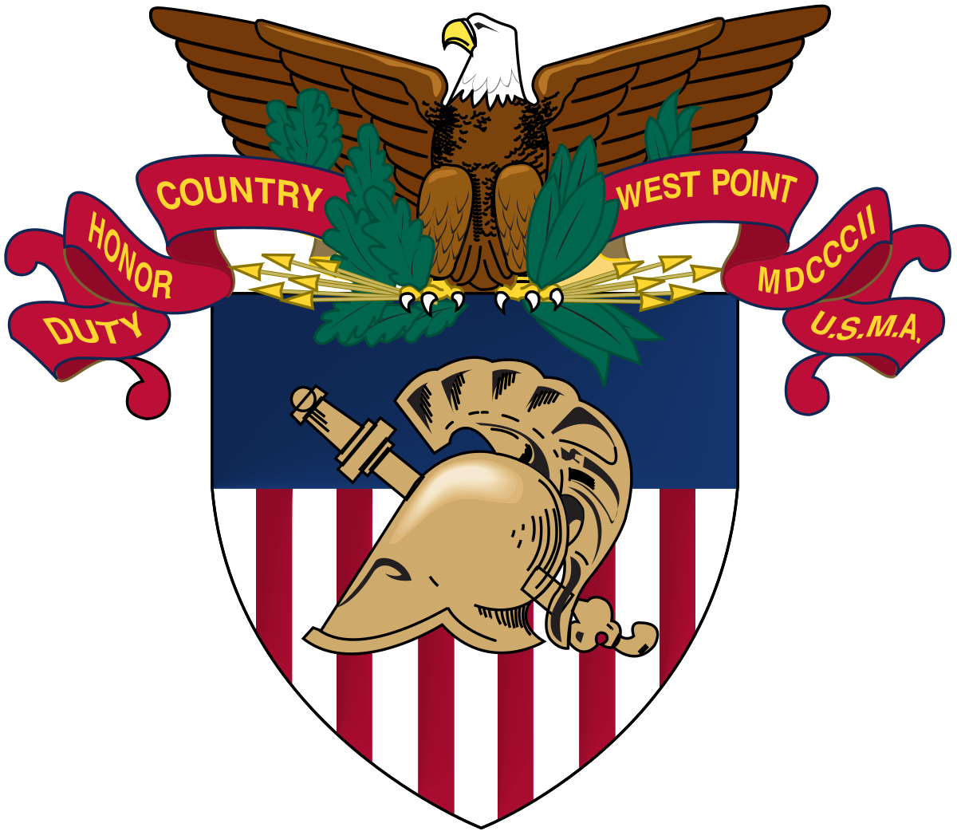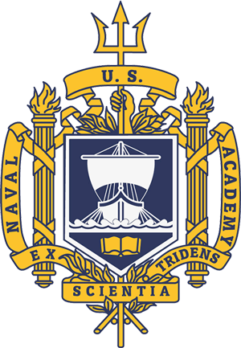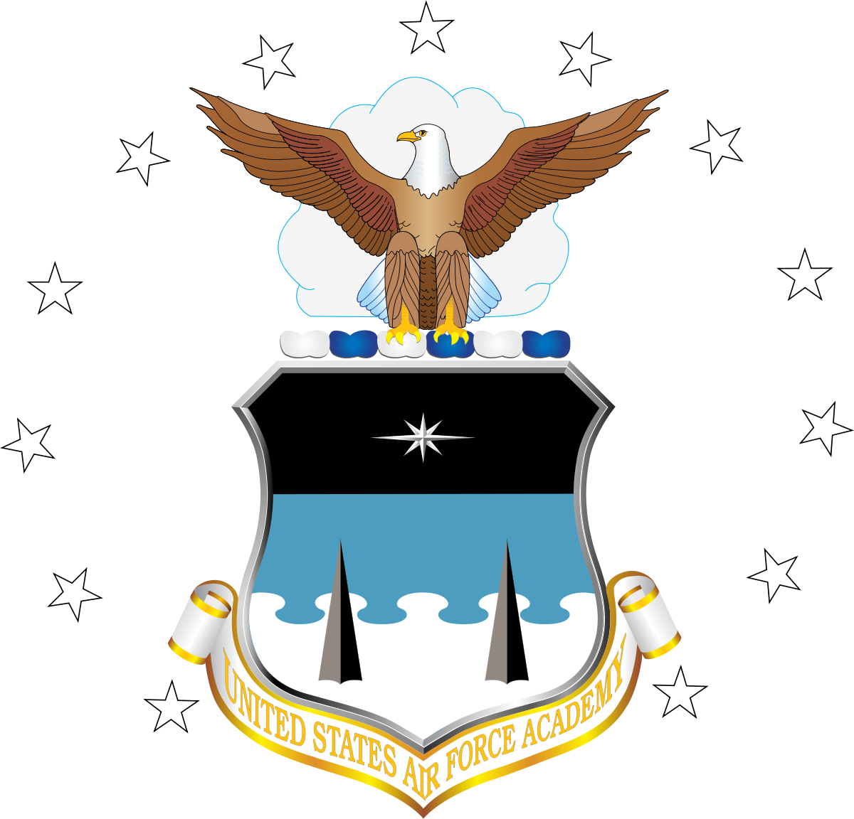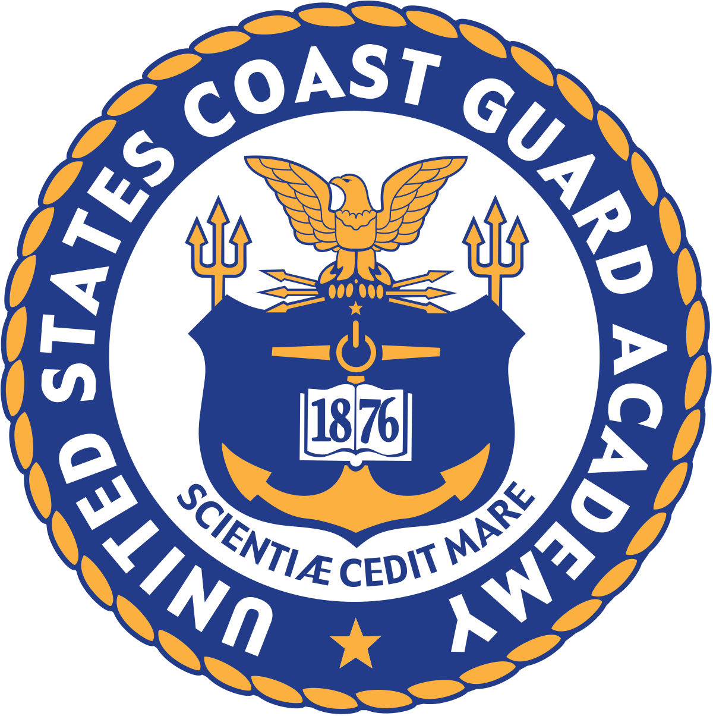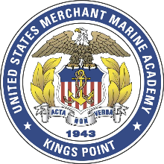

USMA USNA USAFA USCGA USMMA

For More Information Contact:

John Kiernan
Senator Reed’s Office
(401) 943-3100

Hollie Mellen
Senator Whitehouse’s Office
(401) 453-5294

